FOR IMMEDIATE RELEASE

LG INTRODUCES ‘HEALTH PROTOCOL SOLUTIONS’
TO ASSIST ESSENTIAL AND RE-OPENING BUSINESSES

New Suite of Indoor and Window-Facing Digital Signage Packages
Dynamically Communicate Policies, Sanitization Standards, Real-Time Updates

LINCOLNSHIRE, Ill., May 19, 2020 –To help businesses relay important information to their employees, customers, visitors and patients, LG Business Solutions USA has introduced a suite of digital signage packages that allow businesses to dynamically communicate their policies, sanitization standards and real-time updates.

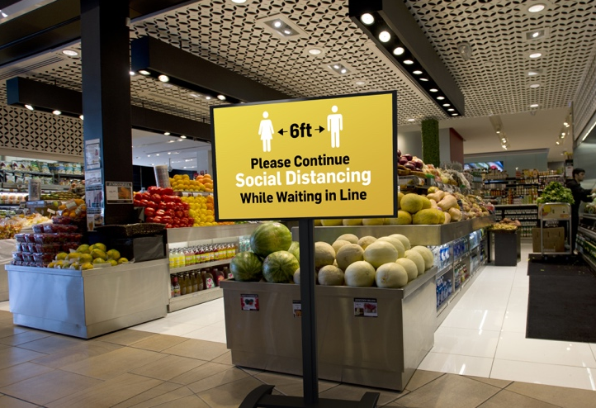
Representing the first in LG’s all-new series of Health Protocol Solutions, these digital signage packages are designed for indoor and window-facing use in either landscape or portrait orientation. Each easy-to-use package includes a webOS Signage™ LG display, a Peerless-AV® SmartMount® Flat Panel Cart and a limited time free trial of content management software (CMS) that’s compatible with multiple webOS Signage software application partners.

“More than ever, relaying important information to employees and customers is critical, and digital signage solutions allow businesses to update messaging as often as necessary, and as quickly and safely as possible,” said Dan Smith, vice president of business development, LG Business Solutions USA. “Our goal is to help businesses during this challenging time with easy-to-use digital signage packages that can be used now for displaying immediate critical messages and re-deployed later to communicate changing health protocols as employees return to the workplace.”

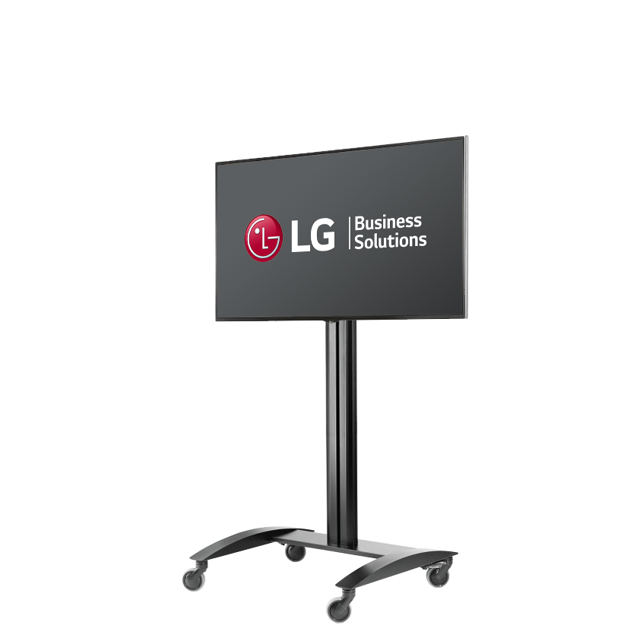
For businesses like restaurants and retailers that require displays that are viewed from outdoors, the package includes a high-brightness 49- or 55-inch window-facing LG display (models 49XS4F and 55XS4F), a Peerless-AV SR560M cart and a free CMS trial. This solution allows retailers and restaurants to relay up-to-date messaging on their health protocols, hours, status, and more to prospective customers.

For other businesses, such as grocery stores, medical clinics, pharmacies and offices that need to convey information to customers and employees indoors, the package consists of three LG display options – 49- and 55-inch 4K UHD models 49UH5C and 55UH5E and 55-inch Full HD model 55SM5KE – each with a Peerless-AV SR560M cart and a free CMS trial. These indoor displays can be used now to relay relevant safety and sanitization guidelines and can be easily repurposed for any other signage requirements later.

LG’s Health Protocol Solutions digital signage packages are available now through select LG distribution partners, with more health protocol solutions coming soon. To learn about these solutions and our special discounted bundle pricing, click here.

For high-res images, click here.

###

About LG Business Solutions USA
The LG Electronics USA Business Solutions division serves commercial display customers in the U.S. lodging and hospitality, digital signage, systems integration, healthcare, education, government and industrial markets. Based in Lincolnshire, Ill., with its dedicated engineering and customer support team, LG Electronics USA Business Solutions delivers business-to-business technology solutions tailored to the particular needs of business environments. LG Electronics USA Inc., based in Englewood Cliffs, N.J., is the North American subsidiary of LG Electronics Inc., a $53 billion global force in consumer electronics, mobile communications, home appliances and air solutions. LG is a 2020 ENERGY STAR® Partner of the Year-Sustained Excellence. For more information, please visit www.LGSolutions.com.

Media Contacts:

LG Electronics USA

Kim Regillio
847 941 8184
kim.regillio@lge.com

Jess Passananti
212 481 3456 x23
jess@griffin360.com

